1. Browse to <https://webmail.fostercity.org>
2. Enter your email address and password on the Outlook Web Access screen:

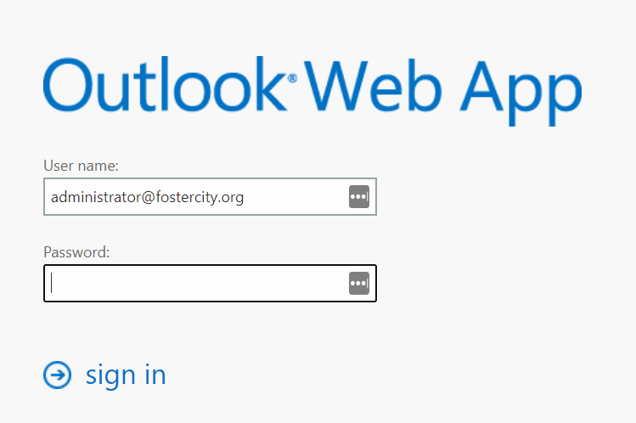

1. You should now be in your inbox. To switch to your calendar, the link is in the upper right:

